Title of Lesson | Time Required | Age Range | Resources required
The Path of Hope | 4 hours | 14-18 | Videos of Syria and refugees on the internet, a globe, a sheet of paper, pens, creative ideas

Lesson Objective | Knowledge and Understanding (Global Theme covered) | Global Skills covered | Global Values and Attitudes covered
To learn about as well as understand the plight of refugees, to get rid of preconceived ideas and be creative | Social justice and equity | Critical and creative thinking | Commitment to social justice and equity

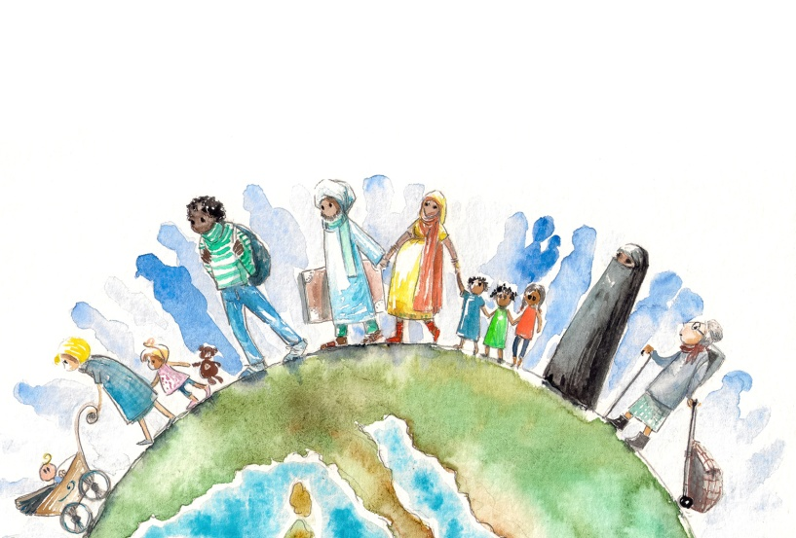
Introduction
This activity describes how informal discussion led the teacher and students to collaborate together to produce a play dealing with migration issues.
During an extra curriculum activity, we talked about the refugee situation. Although students didn’t have practical personal experiences with refugees or asylum seekers, they were aware of the media influence especially in the light of elections where fear of invasion by refugees was exploited by certain political parties. We discussed the theme with questions: What if bombs were dropped on your homes and you had to flee? Would you stay in your countries risking your lives? If you were an unemployed person, from a country not ravaged by war but in a deep economic depression, would you look for some job somewhere in the EU? How would you feel if there was nobody willing to help you? Would you have more chance of gaining asylum if you travelled together as a family?
A few of the students replied they were scared of asylum seekers as we don’t know really who they are. Some of them said they could imagine themselves in the position of refugees. We decided to put ourselves in others’ shoes and to write a play from the perspective of asylum seekers. We had to identify themes and roles within the play. Who would be the main character? What would the story look like? Discussions and planning began.
Main Activity
We then chose the characters. As the students learned ancient Roman history during history lessons I turned their attention to Syria. We had to choose the names. We chose:
Zainab for a female student, after Zenobia, the queen of Palmyra in the 3rd century AD
Mawiya for Zainab’s mother, after the Syrian queen in the 4th century
Rafqa, Zainab’s younger sister, after the Lebanese female saint
Shakir , Zainab’s father, after the famous singer Shakira.
The plot was based around a family of asylum seekers and the challenges faced settling in Slovenia. Together with students we wrote and rehearsed the text of the play. Our play can be downloaded below.
The love theme between Slovenian student and Zainab served as an example of integration of migrant students into the class and the success of a dance performance by Zainab and her team served as a proof that every migrant has abilities to contribute to the society.
Plenary
Students read the script taking different roles as a stimulus for discussion.
This led us onto reflection questions such as:
If you were Shakir, Mawiya, Zainab and Rafqa, what would you do in Slovenia?
Would you be jealous of someone who is of different ethnicity, religion, colour?
If you were a migrant student in the classroom how would you feel?
Does everyone have some abilities to share?
What were the Outcomes?
Students became more aware of the plight of refugees and they could identify with them. It enabled them to explore contemporary issues and multiple perspectives through a creative approach.They liked idea of being creative and contributing their own ideas to shape the story. if time permits next school year some of them would like to perform the story for other students.

A play, written for this activity, can be downloaded here.
A song written for this activity was also created, entitled "Skupi Stopmo" ( Let's Get Together) - you can listen to it here.

